Improve employee engagement through recognition & reward

For Microsoft Office 365, Yammer and SharePoint 2013

February 2015

|  |  |
| --- | --- |
| Author: Sasja Beerendonk |  |
| Sasja | *After graduating as a history teacher I started doing ICT training. Currently I work as a user adoption consultant to help clients get more from their collaboration platform.*  *I consult with clients on an adoption strategy for their (social) collaboration software. Not only is technology and functionality addressed, but also organizational and behavioral aspects, as tools are used in specific context for an improved way of sharing knowledge, collaborating and communicating.* |
|  | |
| Connect with Sasja on [**Twitter**](https://twitter.com/sbeerendonk) (@sbeerendonk) and [**LinkedIn**](http://nl.linkedin.com/in/sbeerendonk), and check out her blog [**here**](http://thoughtsoncollaboration.com/)**!**  Email: [s.beerendonk@silverside.nl](mailto:s.beerendonk@silverside.nl)  Silverside, Capelle a/d IJssel, Netherlands | |

Contents

Improve employee engagement through recognition & reward 3

Improving collaboration 3

Gamification: techniques for recognition & reward 4

What is gamification? 4

The evolution of gamification 4

Flow 5

Employees in the flow of a new way of working 5

What motivates us? From Maslow’s needs to Pink’s Drive. 6

Sticks & Carrots, or a path to sustained adoption 6

Behavior model 7

Behavior loop 8

Measure, reward, enhance 10

Encourage employees to engage in desired behavior 10

Rewards & Recognition examples 12

Profile completeness and progression 12

Getting Started progress bar 12

Praise 12

Leaderboards 13

Likes and ratings in lists and libraries 13

Badges and reputation in a SharePoint community site 14

Rewards & Recognition apps for SharePoint online or SharePoint 2013 15

Mavention’s Profile completeness 15

Employee of the month / Featured Employee 16

Badgeville for SharePoint & Yammer 16

Sources 17

# Improve employee engagement through recognition & reward

[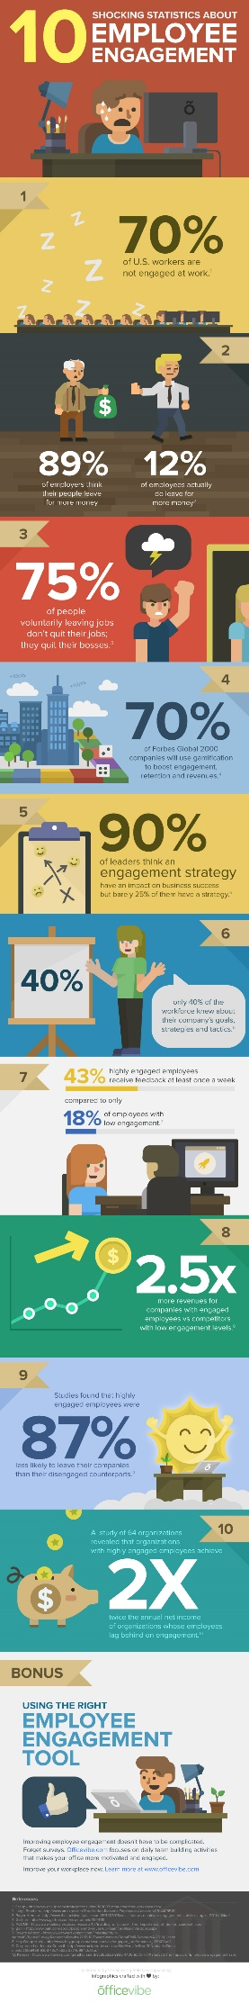](http://www.officevibe.com/blog/stats-employee-engagement-infographic)Do you have engaged employees? Research states that worldwide, 13% of employees are engaged at work. 63% are ‘not engaged’. Meaning they lack motivation and are less likely to invest discretionary effort in organizational goals or outcomes. 24% are ‘actively disengaged’, indicating they are unhappy and unproductive at work and liable to spread negativity to coworkers.

Companies with engaged employees see 240% improvement in business results:

* Higher productivity
* Higher profitability
* Higher Customer ratings
* Less turnover and absenteeism
* Fewer safety incidents

Traditional methods of driving engagement

* Training and manuals
* Mandates and policies
* Operational metrics for learning, satisfaction, and performance
* Collaboration software to encourage employees to communicate, share and learn

# Improving collaboration

More and more organizations use a collaboration platform such as SharePoint or Office 365 to facilitate collaboration and knowledge sharing between employees. Organizations aim to make better use of the knowledge and skills of their employees with these platforms. Thus, employees will have to effectively share knowledge and collaborate. Collaborating in a social platform is different than collaborating with other tools, such as an ERP system: collaboration is in a more open manner, more transparent and interactive, without a very clear path to follow.

The mere implementation of a collaboration platform itself does not change the routines and attitude / behavior of employees. Implementation is often assumed to only contribute to 10% of the success of developing into an organization where knowledge is shared openly and collaboration is efficient and effective. The other 90% of the success lies in its people – employees - and their adoption of the new platform.

How do you get people willing to change their behavior and attitudes? How do you ensure that all employees understand the importance of the change? How will they learn how to collaborate? Attention to user adoption provides 90% of success!

# Gamification: techniques for recognition & reward

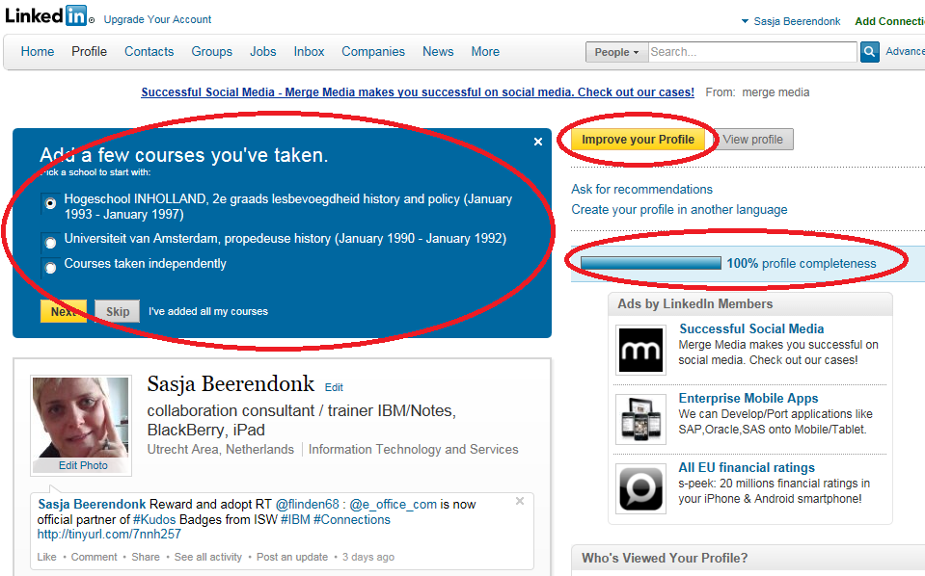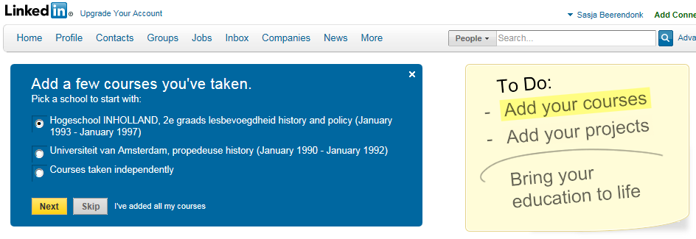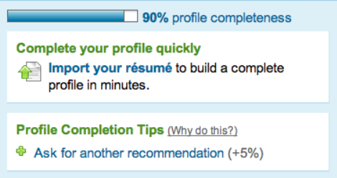

One good way to enhance adoption is to use **game mechanics**. With game elements, employees are being stimulated to take part in, and learn how to effectively use the tools.

The word *gamification* often puts people off. But for a better understanding of what we are talking about however necessary. But be aware: It’s about *meaning*, not flair. It’s about *pursuing purpose*, not leaderboard points!

## What is gamification?

*Gamification is the use of game elements and game design techniques (mechanics) to enhance non-games. Typically gamification applies to non-game applications and processes, in order to encourage people to adopt them, or to influence how they are used.*

Also, don’t think of gamification as a magic wand that will solve your business problem. It only solves your engagement problem. Think of gamification as a way to provide recognition and reward: as a system to reward and recognize employees for their achievements or contributions. Rewards and recognition could be given by the system, by a secluded group, or peer-to-peer.

## The evolution of gamification

Gamification isn’t really new. It’s been around in consumer areas for a long time. And most likely, you are already familiar with it. Just think of the frequent flyer programs where airlines give you points for mileage, and award things with maybe a gold status, which will buy you free tickets or upgrades, encouraging you to fly their airline more and more.

But also foursquare uses mayors and badges, even combined with check-in at Starbucks, buying your loyalty. Another one that’s gotten very popular is the Nike+ runners app which will encourage you to run more, further, faster, and even makes it into a social event with your friends using the app. And how about cars these days? Helping you to be a better driver, when it comes to fuel use and the environment, using the car’s board computer.

What all these have in common, is they encourage people to work hard to get better, go further, and keep coming. Now, isn’t that what we would like our employees to do as well? We would like employees to try out new features and functionalities, get better with them, and keep coming to our platform to share their knowledge and expertise.

Many of us are also familiar with similar game elements in social platforms. Just think of LinkedIn, which uses game elements to get you to fill in your profile with information about your skills, certification, education and projects. Something most of us don’t really do, as it takes up a lot of time. When they introduced the profile progress element people added more information to their profile. Another feature that LinkedIn uses is endorsement: you can endorse people in your network with skills and expertise, and it even helps you with suggestions who to endorse with what skills!

## Flow

Why are game techniques so succesful? Because people are willing to spend a lot of time, working hard, trying over-and-over again to get better and go further in games. But why is that?

Phil Toledano photographed gamers while they were gaming to capture their emotions.



For a non-gamer some nuances might be lost. They usually see some urgency, and a tad of anxiety and also the deep concentration that makes you think the gamer is solving a huge problem. But gamers might recognize the twist around the eyes and mouth which is a sign of optimism. The eyebrows are up, which is a sign of surprise. This person is on the verse of an ‘epic win’. An epic win is a result that is so exceptionally positive you didn’t know it was possible until you reach it. And when you reach it, you’re surprised it was even possible. Gamers reach such an epic win, because they are in the flow, as described by Mihaly Csikszentmihalyi: A mental state of operation in which a person performing an activity is fully immersed in a feeling of energized focus, full involvement, and enjoyment in the process of the activity.

Applying these methods in the workplace can improve morale by fostering a sense of greater happiness and accomplishment, and in correlation to increased performance.

In order to achieve flow, Csikszentmihalyi lays out the following three conditions:

* Goals are clear
* Feedback is immediate
* A balance between opportunity and capacity

## Employees in the flow of a new way of working

When we want employees to start using our collaboration platform to their fullest, often requiring a new way of working, the adoption strategy most used is providing training or sometimes even just a manual. But we all know people don’t really read the manual. And training is expensive, both in time and in money.

On average the time spent on games or gamified activities for a gamer is 10.000 hours until the age of 21. This is actually equal to the time spent on an entire primary education! 10.000 hours is a remarkable number: it is also mentioned in ‘’Outliers’’ by Malcom Gladwell, as the 10.000 hours success theory. Cognitive scientific research states that if we study hard for 10.000 hours we become virtuosos.

If we could only engage our employees to put in as many hours to learn about and work with collaboration software such as Office 365!

Adoption is about changing employees’ behavior. The new software allows them to do their work in a new way. Adoption can help them transition from the way they do their work into a new way of working.

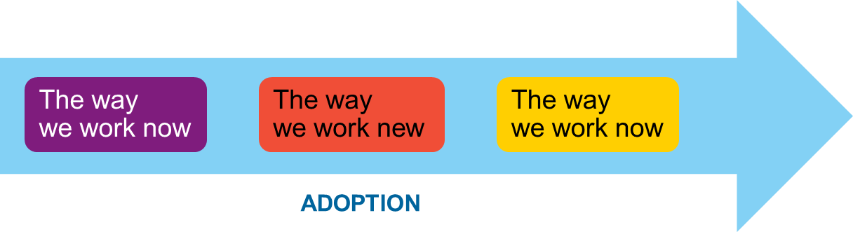

The purpose and benefit of an adoption approach is to help employees and organizations understand and engage in social collaboration.

Gamification can point employees into the right direction to enhance efficiency and effectiveness through social collaboration. They often find themselves wondering how to start, feel overwhelmed or don’t see the benefit of a new way of working. What steps should be taken to share knowledge? Gamification can point in the right direction, step-by-step. To guide employees to see purpose and value in the collaboration.

## What motivates us? From Maslow’s needs to Pink’s Drive.

Maslow used the terms ‘physiological’, ‘safety’, ‘belongingness’ and ‘love’, ‘esteem’, ‘self-actualization’ and ‘self-transcendence’ to describe the pattern that human motivations generally move through. Maslow's hierarchy of needs is often portrayed in the shape of a pyramid with the largest, most fundamental levels of needs at the bottom and the need for self-actualization at the top.

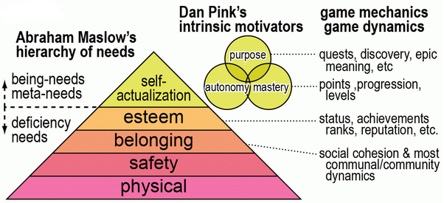When it comes to the 21st century (at least for us lucky few in developed countries) people usually have the first layers of the pyramid covered. It is the top layers belonging, esteem and self-actualization that are important motivators for us.

Dan Pink argues that human motivation is largely intrinsic, and that the aspects of this motivation can be divided into autonomy, mastery and purpose. He argues against old models of motivation characterized as carrots&stiks, driven by rewards and fear of punishment, dominated by extrinsic factors such as money.

## Sticks & Carrots, or a path to sustained adoption

The threat of punishment is the highest motivator for short-term change, followed by the promise of financial reward, but both deliver only short-term gains. For long-term change, increased utility is the highest motivator.

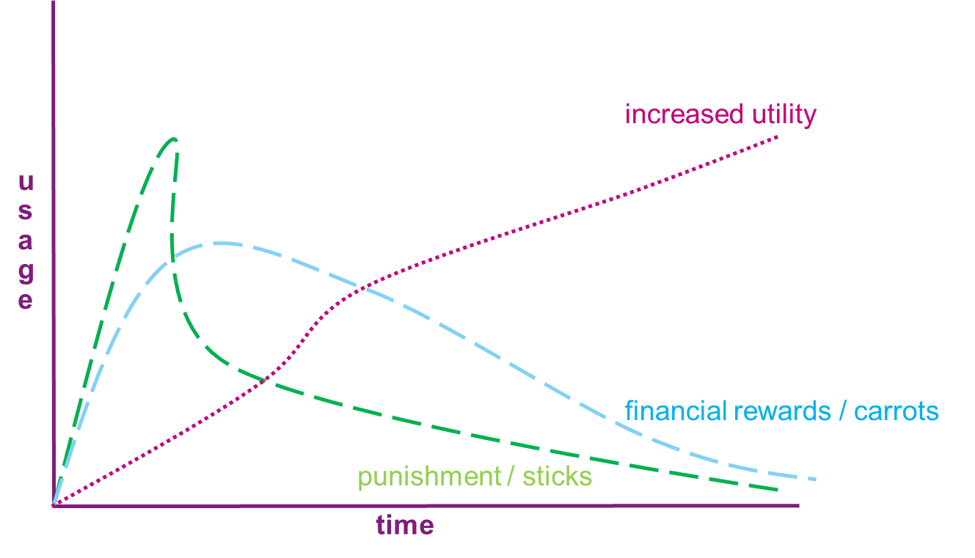

How do we achieve increased utility? In other words, how can we get employees to start using – and keep using – the platform for daily work activities? We need to change their behavior.

## Behavior model

Let’s dive a bit deeper into the workings of game dynamics. Remember what we are trying to achieve is to change the way people do their work from the way they work now, to the way they work new (with the new collaboration tools) until it finally is an automatic habit and again becomes the way we work now. For this process to happen we need employees to change their actions and behavior.

Why and how can gamification stimulate change in actions and behavior? Behavioral science states there are 3 factors for human behavioral change:

* Motivation
* Ability (time, attention, mental capacity, resources)
* Trigger (timing, suggestion at the right moment)

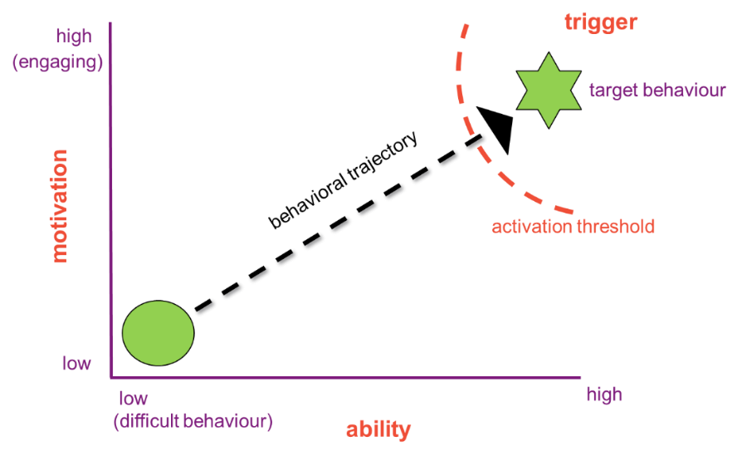The Fogg Behavioral Model (FBM) asserts that for a person to perform a target behavior, he or she must (1) be sufficiently motivated, (2) have the ability to perform the behavior, and (3) be triggered to perform the behavior. These three factors must occur at the same moment, or else the target behavior will not happen.

In the upper right hand corner is a star that represents the target behavior. The placement of this star is symbolic, meant to suggest that high motivation and high ability are typically necessary for a target behavior to occur. To emphasize this relationship between motivation, ability and target behavior, Figure 1 also has an arrow that extends diagonally, from the bottom left corner to the upper right. This arrow, as the words on the figure say, indicates that as a person has increased motivation and increased ability, the more likely it is that he or she will perform the target behavior. The third factor in the FBM is a trigger. Without an appropriate trigger, behavior will not occur even if both motivation and ability are high.

When all 3 factors are present at the same time, people can be stimulated to do certain actions (target behavior). It is particularly these 3 factors motivation, ability and trigger that gamification focuses on.

## Behavior loop

When gamification is applied properly it becomes an engagement mechanism for collaboration behavior which overcomes the natural incapacity of people and organizations to effectively collaborate towards a common goal.

By applying a system of incentives (extrinsic and intrinsic rewards), employees are guided towards a desired behavior, which in turn will influence a positive outcome (desired results / set goals).

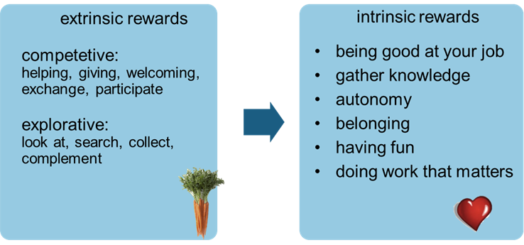 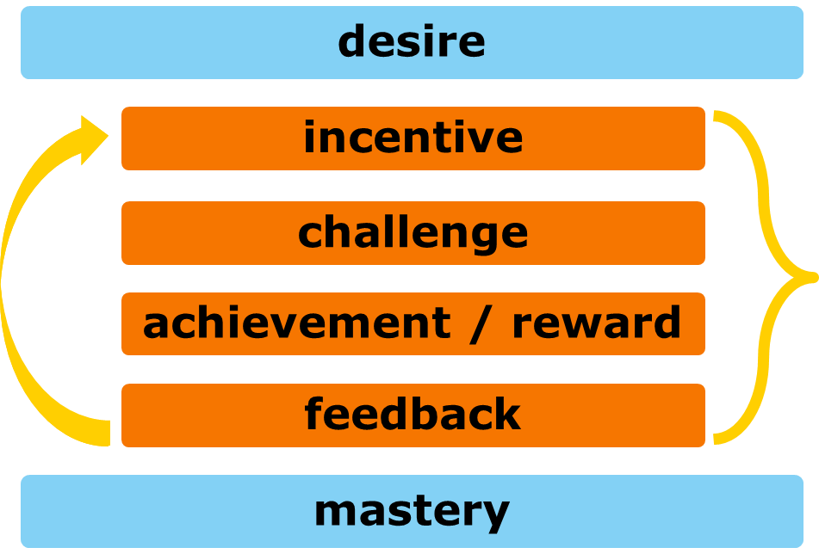

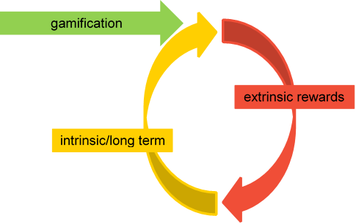When an employee is doing a certain activity on the platform, he or she is creating value in itself. When employees start to realize this, the extrinsic motivation will become less and less important. The whole reward system will become secondary to the value created, which in turn will become the most important motivator.

This positive feedback loop changes the gamified activity into an intrinsic motivation.

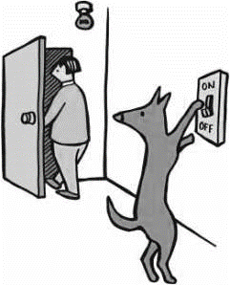

# Teaching a dog to turn on the light

Did you ever try to teach your dog to turn on (or off) the light? It’s been done. But of course it’s not just simply telling your dog “turn on the light, Bello!” To a dog, this is actually a complex exercise, containing many concepts and a series of actions.

What is needed is that you provide a clear path. Training involves:

* Small steps
* Instant feedback
* Positive rewards

In fact, you will need to teach the dog a chain of events, breaking-up the whole series into small steps, provide instant feedback (click), followed by a positive reward (treat).

There a few difficulties for the dog: the switch is unfamiliar, and also the fact it can switch. The switch on the wall is usually way too high to reach, so you will need aids to get the dog to reach it (attach it to a plate at medium height first, and use a chair to jump on to reach the actual switch).

The whole series of complex actions can be broken down into the following small steps:

1. Touch the light switch in your hand (separate from the wall)
2. Flip the light switch with nose or paw
3. Touch a plate with her nose
4. Attach the switch to a plate and repeat steps 1-3.
5. Change the position of the plate (put it up right in your hands) and repeat steps 1-3.
6. Position the plate on the wall and put a chair underneath it.
7. Let the dog jump on the chair.
8. Put together the steps 2-3 and 7 (chair and the switch): Jump on the chair + flip the switch

[Watch this video](https://www.youtube.com/watch?v=b7nxeSQ-VKE) to see the clicker training in action.

**Clicker training – Teaching a chain of actions**

*Clicker training is a way of training animals by reinforcing the behaviors you like, so they’ll happen again.*

*The ‘clicker’ is a small noisemaker that makes a distinctive ‘click’ sound when the metal tab is pressed. The clicker is intended to tell your dog when he or she does something correctly. Once you've trained your dog to associate the clicker with rewards, he or she will quickly learn that when she performs a behavior and you click, (s)he will receive a reward. This means that your dog will be an active participant in the training process, instead of just being forced into position.*

# Measure, reward, enhance

Gamification works by making technology more engaging, by encouraging users to engage in desired behaviors, by showing a path to mastery and autonomy, and by taking advantage of humans' psychological predisposition to engage in gaming and respond to recognition and rewards.

|  |  |
| --- | --- |
| Game mechanics | Behavior motivators |
| Points | Reward |
| Levels | Status |
| Badges | Achievement |
| Leaderboards | Competition |
| Challenges | Self-expression |
| Feedback | Altruism |

With gamification elements such as points, badges, missions, leaderboards, ratings – and of course fun – employees are motivated to work towards a common goal with a desired outcome. While they work they receive visible rewards, appreciation of their peers and managers, a sense that they matter, and being part of a bigger picture, and other psycho-social rewards that can lead to the apex of Maslow’s hierarchy.

**Measure** Set goals, levels, points and measure if they are met.

**Reward** Give feedback, give badges, show the best.

**Enhance** Indicate what needs to be done to go further, invite to use advanced functionality or show desired behavior.

## Encourage employees to engage in desired behavior

When implementing a new tool, employees might not easily embrace the new way of working that is required. People often have a natural resistance to change.

Some roadblocks to change:

* Fear of the unknown
* Comfort with the status quo
* Pushback on being forced to change
* No sense of the future possible benefit
* Being overwhelmed with possibilities
* Change is a process not an event  
  Change doesn’t happen in an instant. there is a process to be worked through.
* Change takes time  
  People have to re-wire the way they work, and re-factor the habits they have internalized about how work is done.
* Change is made real by what people do  
  Change starts as an idea (future state) and becomes increasingly real through a process of discussion, exploration, experimentation, learning and mid-course corrections.
* Change is social  
  The right people can have a large impact on the introduction of change. Early opinion leaders who model the desired change, and win early converts, can fundamentally rewire the way groups and communities work together.

Gamification is about taking the things in games that motivate us, such as goals, rapid feedback, competition, milestones, achievable challenges, recognition and rewards, to encourage us to be productive and engage in one or more desired behaviors.

Game techniques can encourage people to perform chores that they ordinarily consider boring, such as completing surveys, filling out forms, or reading manuals. Also, game techniques guide employees with laying out the next steps, and providing feedback when achievements are accomplished.

What games do very well is encourage hard work. What we need is gamification to provide step-by-step guidance and stimulation for an employee to become more involved and actively participate in the platform.

Improve engagement by providing:

**Rapid or even instant feedback** — Traditional businesses feedback cycles are much longer - monthly, quarterly or even annual, which may result in employees losing focus on their goals. Gamification gives you the visual reward when you have finished the actions required: you receive a Badge, you get a notification in your newsfeed/activity stream, and it shows your position in the Leaderboard. By showing progress, displaying points, badges and leaderboards employees get much faster feedback.

**Clear goals and rules** — In all but the simplest environments, there are lots of “grey areas” when determining how to achieve goals or what should be done, which can be frustrating.  
By taking small steps, starting with filling out your profile, expanding your network, doing the first updates, it can help employees overcome cold feet. Or prevent an employee from being overwhelmed by the wide range of possibilities.

**A compelling narrative** — Participants in a game receive incentives to achieve their goal in addition to their internal motivation.   
Gamification shows what small steps you may take at any time. And it also shows what the value of these steps is: of both the work in the platform itself as in measurable points: number of likes, ratings, downloads and replies, best answers.

**Tasks that are challenging but achievable** — One of the key concepts in games, and therefore gamification is having the right challenge which can be attained by working hard.

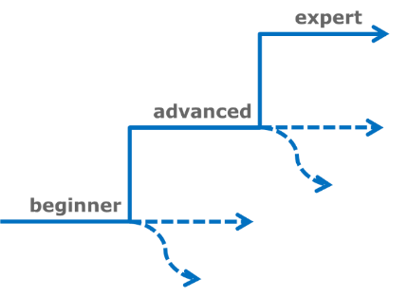  
A user is constantly taken to a higher level, to continue, to do more. There is no failure. You can always try to get the points again. Failure is therefore just an incentive to work even harder!

# Rewards & Recognition examples

There are many examples of gamification for Office 365. Some are free, default, and some you need to buy. Some are very basic, others are quite extensive. This is by no means a full and definite list. As with tools in general and also with add-ons for rewards & recognition there is a continuously evolving and changing market. What I will do is give some examples of what is possible.

## Profile completeness and progression

Within Yammer there are three features available by default:

* Getting Started progress bar
* Praise
* Leaderboards

### Getting Started progress bar

When you get on board with Yammer there is progress bar at the top, clearly stating your progression, and what next steps you need to take to get ahead.

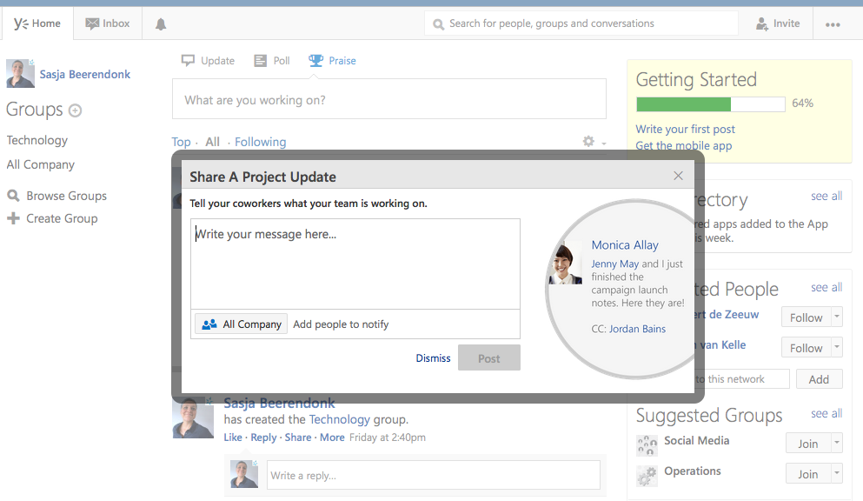

The progress bar is very basic. Not taking you very far, but at least it stimulates employees to start doing some first, basic steps in the onboarding process.

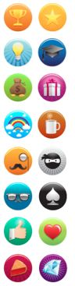

## Praise

Show your appreciation to your peers and colleagues! With Yammer, employees can use peer-to-peer rewards by posting a Praise badge of their choice in the activity stream. Peer-to-peer recognition is an excellent way to motivate and engage.

Unfortunately Yammer doesn’t allow you to create your own company badges, decide who can award them and to whom and hwo often, or even tell you what the badge image actually stands for. It is, therefore, important to have some guidelines on the available badges and align them somewhat to your company goals and values.

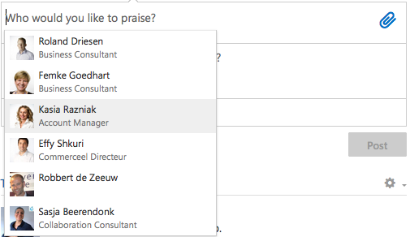 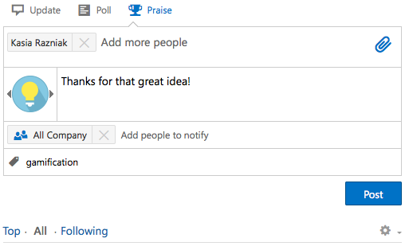

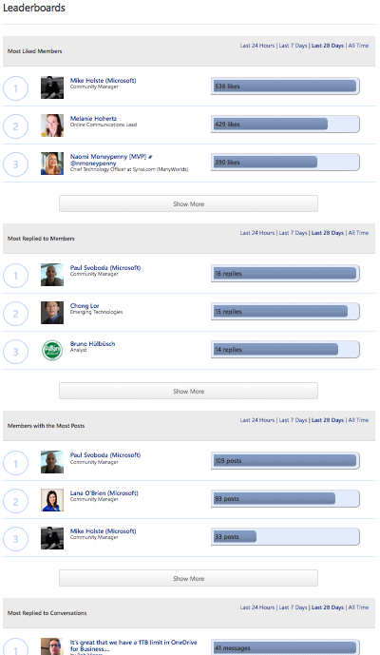

## Leaderboards

Leaderboards gives users access to statistics about their activity on their Yammer network. The Leaderboards include:

* **Most Liked Members**: Top 10 users whose messages have received the most ‘Likes’
* **Most Replied to Members**: Top 10 users whose messages have received the most replies
* **Members with the Most Posts**: Top 10 users with the most public messages posted
* **Most Replied to Threads**: Top 10 threads with the most replies
* **Threads with the Most Participants**: Top ten threads with the most participants

## Likes and ratings in lists and libraries

For any List or Library we can turn on likes or rating settings. These are not turned on by default, but can in fact be very helpful in growing engagement. When turning on rating we can decide whether we would like to use *Likes* or *Star Ratings*.

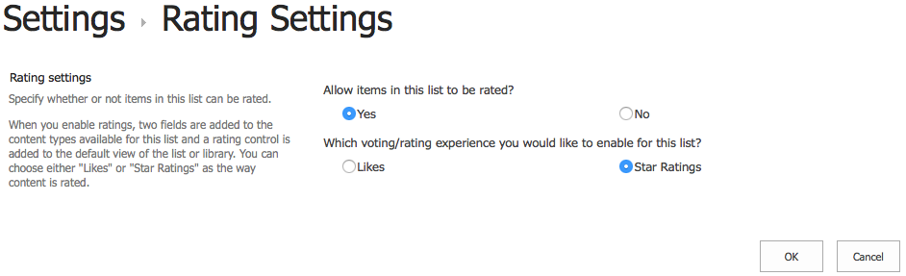

## Badges and reputation in a SharePoint community site

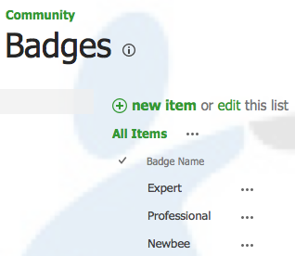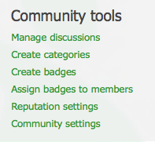Badges in the SharePoint community site can be used to recognize the special members of the community. The site owner can create custom badges, depending on the recognition needs of the organization. By default the community site has 2 badges: Expert and Professional. But a badge could reflect anything you would like, for example: a certification status, or company awards, or any participation you would like to give kudos for.

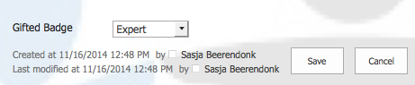

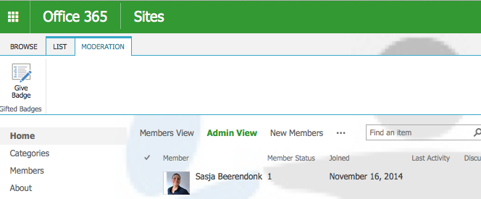



The Community site also has some **Reputation settings**, extending the standard Rating settings for lists and libraries, mentioned earlier. Instead of just choosing to turn on likes or ratings, we can now also earn points and achieve levels when accumulating points. Assign a certain number of points for creating a new post, replying to a post, get likes or 4-5 star ratings on your posts, and points for getting marked as the best reply to a post.

Once turned on, the Reputation settings will be used to display something a bit like a leaderboard for the Community. In the *Members* section we can see a list of **Top contributors**: The list keeps record of ongoing activity by members and reputation they accrue within that community.

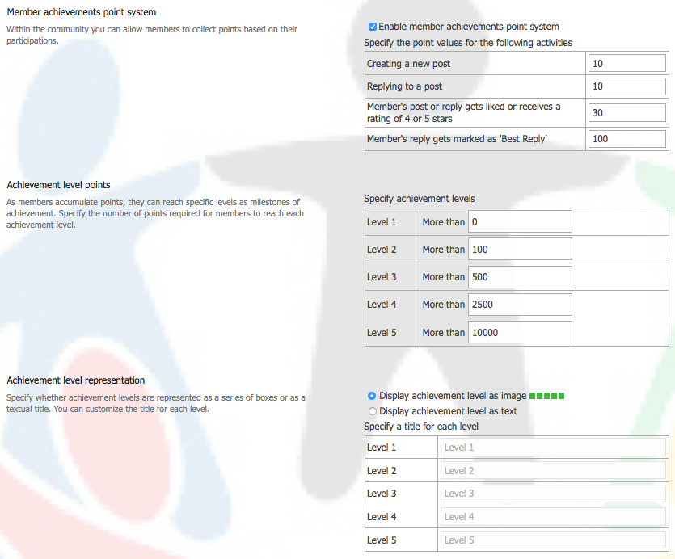

There are a few factors that leave room for improvement with Badges and Reputation.

* They are not really badges, but just text. All badges received are displayed with the same icon (small ribbon). It would be much better to visually display the badge, with an icon that’s easy to recognize what you are being rewarded for.
* You can only ‘own’ one badge at a time. So when configuring badges for your team site, you need to think carefully about the progress of badges, since you can not get more than one type of badge. This isn’t very stimulating, so definitely could be improved by Microsoft.
* Badges visually intervenes with the Reputation settings (likes & rating) available.

## Rewards & Recognition apps for SharePoint online or SharePoint 2013

There are ways to enhance what is available by default for Office 365. Several apps are available in the Office store, for profile completeness, awards and recognition.

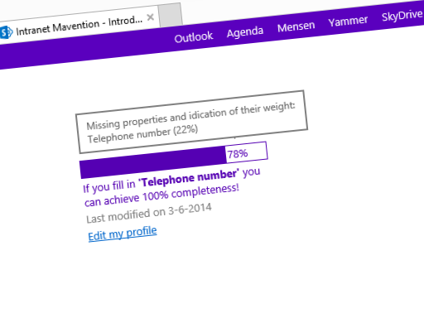

### Mavention’s Profile completeness

This free app encourages users to fill in the blanks on their profile. By confronting them with real-time statistics on how far their profile is completed they will have an incentive to fill in missing information.

### Employee of the month / Featured Employee

Recognize employees within your organization by awarding them Employee of the month (or week, or year).

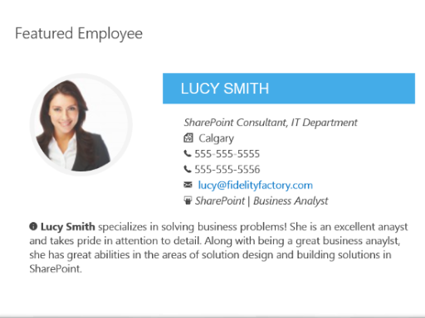 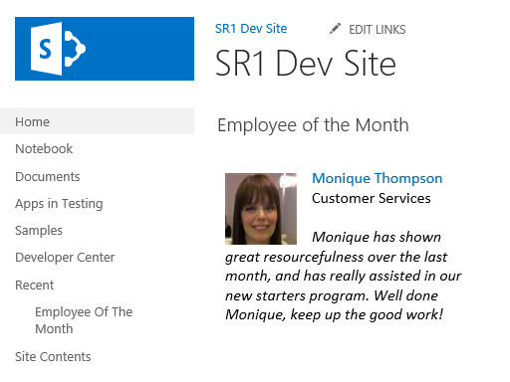

### Badgeville for SharePoint & Yammer

Badgeville for SharePoint uses points, achievements, missions, levels, and leaderboards to incentivize and reward employees to share expertise, knowledge and best practices.

Game Mechanics guide employees with instant feedback on the valuable behaviors they perform:

* Creating or editing a Document, a Wiki page, or creating and updating a Task
* Starting or participating in a Discussion thread
* Commenting on content (Docs, Wikis, Blogs)
* Creating or editing to an Announcement
* Viewing pages
* Rating, Liking and Tagging content

Social Mechanics give individuals context of what the group is doing, and Reputation Mechanics surfaces and highlights their expertise.

Administrators can use the Behavior Engine to create custom behaviors, Achievements, and Missions for SharePoint sites.

Badgeville for Yammer enables companies to measure, influence, and reward key user behaviors, and publish them into Yammer’s Activity Stream as contextually relevant updates. A reward can have whatever description or status a company chooses, and can support a network-wide reputation system.

# Sources

A.H. Maslow, “A Theory of Human Motivation” (in Psychological Review, 50, 370-396 1943).  
<http://www.altruists.org/f62>

Daniel H. Pink, “Drive: The Surprising Truth About What Motivates Us” (2011).

Gallup, “State of the Global Workplace: Employee Engagement Insights for Business Leaders Worldwide” (Report, 2014).  
<http://ihrim.org/Pubonline/Wire/Dec13/GlobalWorkplaceReport_2013.pdf>

Gartner Newsroom “Gartner Says By 2015, More Than 50 Percent of Organizations That Manage Innovation Processes Will Gamify Those Processes“ (Egham, UK, April 12, 2011).  
<http://www.gartner.com/newsroom/id/1629214>

Harvard Business Review Analytic Services, “The Impact of Employee Engagement on Performance” (Harvard Business School Publishing, 2013).  
<https://hbr.org/resources/pdfs/comm/achievers/hbr_achievers_report_sep13.pdf>

Infosys Labs Briefings, “Gamification” (Vol.11 Nr. 3 2013)  
<http://www.infosys.com/infosys-labs/publications/Documents/gamification.pdf>

Jane McGonigall, “Reality Is Broken "(2011)  
[http://www.ted.com/talks/jane_mcgonigal_gaming_can_make_a_better_world.html](http://translate.google.com/translate?hl=nl&prev=_t&sl=nl&tl=en&u=http://www.ted.com/talks/jane_mcgonigal_gaming_can_make_a_better_world.html)

Malcolm Gladwell, “Outliers: The Story of Success” (2011).

Michael Sampson, “User Adoption Strategies” (The Michael Sampson Company, July 2012).

Michael Wu, Ph.D., "The Magic Potion or Game Dynamics” (2011).  
<http://community.lithium.com/t5/Science-of-Social-blog/The-Magic-Potion-of-Game-Dynamics/ba-p/19260>

Michael Wu, Ph.D., "Gamification 101: The Psychology of Motivation” (2011).  
<http://community.lithium.com/t5/Science-of-Social-blog/Gamification-101-The-Psychology-of-Motivation/ba-p/21864>

Michael Wu, Ph.D., "The Backlash Gamification + Two Long Term Business Strategies” (2011).

Mihaly Csikszentmihalyi (1990). “Flow: The Psychology of Optimal Experience” (Harper & Row. 10 November 2013).

Oscar Berg, “Social Collaboration vs The Existing Communication Culture” (December 14th 2011).  
<http://www.thecontenteconomy.com/2011/12/social-collaboration-vs-existing.html>

Rajat Paharia, “Loyalty 3.0: How to revolutionize customer and employee engagement with Big Data and Gamification” (2013).

TED talk Tom Chatfield, “7 ways games reward the brain”  
[http://www.ted.com/talks/lang/nl/tom_chatfield_7_ways_games_reward_the_brain.html](http://translate.google.com/translate?hl=nl&prev=_t&sl=nl&tl=en&u=http://www.ted.com/talks/lang/nl/tom_chatfield_7_ways_games_reward_the_brain.html)

Tim Royle - Guest Blogger, Executive Director ISW, "Gamification: Unlocking hidden potential collaboration”.  
<https://www-304.ibm.com/connections/blogs/socialbusiness/entry/gamification_unlocking_hidden_collaboration_potential2?lang=en_us>